|  |
| --- |
| SOUTHERN CROSS UNIVERSITY |

**ASSIGNMENT COVER SHEET**

For use with online submission of assignments

Please complete all of the following details and then make this sheet the **first page of each file of your assignment – do not send it as a separate document.**

Your assignments must be submitted as either **Word documents, text documents with .rtf extension or as .pdf documents**. If you wish tosubmit in any other file format please discuss this with your lecturer well before theassignment submission date.

|  |  |
| --- | --- |
| Student Name: | Shona (Guo xiu) |
| Student ID No.: | 202200408085 |
| Unit Name: | Systems Analysis & Design |
| Unit Code: | ISYS1005 |
| Tutor’s name: | Viettrung Luong |
| Assignment No.: | Assignment 2 |
| Assignment Title: |  |
| Due date: | 10.26 11.59PM |
| Date submitted: | 10.26 7.05AM |

Declaration:

*I have read and understand the Rules Relating to Awards (*[*Rule 3 Section 18 – Academic Misconduct Including Plagiarism*](http://policies.scu.edu.au/view.current.php?id=00140#s18)*) as contained in the SCU Policy Library. I understand the penalties that apply for plagiarism and agree to be bound by these rules. The work I am submitting electronically is entirely my own work.*

|  |  |
| --- | --- |
| Signed:  (please type your name) |  |
| Date: |  |

Contents

SOUTHERN CROSS UNIVERSITY 1

Investigating System Requirements 3

Fact-finding techniques: 3

Interview Plan 3

Use Case Diagram 4

Use Case 4

Activity Diagram 6

ERD 7

Database Design 7

Database Schema 7

Alternative Options 7

Analysis 8

Recommendation 8

Conclusions 8

Bibliography 8

# Investigating System Requirements

## Fact-finding techniques:

**1. Questionnaires. Reason**: Understand your needs for the new system through a questionnaire that surveys your users. The results of the survey can better understand the needs of users and improve the update system.

**2**. Understand the needs. **Reason**: System users and the staff who wrote the system meet and talk to find out what they are not satisfied with the existing system, and will gradually change and adapt it in the new system.

**3**. Practical visits. **Cause**: Observe the usage of the system. At the same time, it has an in-depth understanding of the actual system operation process and business process, and then finds out and finds the problems and bottlenecks in the system, so as to provide a basis for the improvement and design of new systems in the future.

**4**. Research literature.**Cause**: Flip through relevant materials to understand possible future trends. Find out where the new system is going to go and further improve the problems of the existing system.

**5**. Take advantage of prototype testing.**Cause**: We first prototype the system, then let users experience it, and finally collect their feedback and suggestions. This test provides information about their needs and preferences for the new system.

**6**. Interview with experts in the relevant field. **Reason**: Have in-depth exchanges with experts and scholars in related fields to understand their views and suggestions on the new system, so as to judge whether the direction of the new system is correct.

**7**. Reference industry standards and competition.**Reason**: Use relevant industry standards and norms as a reference to study your competitors' systems to understand their attractive features. By comparing the gap between the competitor's system and the previous system, we can determine where the new system is going.

**8**. Understand successful cases in the industry to provide basis and competitiveness for the design of new systems System and data analysis.**Reason**: The use of system and data analysis tools can clearly display the system components and data information, so as to better write the system and clarify the requirements of the system.

**9**. Check the document**: 1.** Describe the problems and requirements of the database. Useful resources include internal memos, e-mails, meeting memos, employee customer comments, and problem description documents. **2.** Describe the business affected by the problem. Useful resources include organization chart, task statement, business strategic plan, some task objectives being studied, examples of manual forms and reports, examples of calculation forms and reports, and completed forms / reports.  **3.** Describe the current system. Useful resources include different types of data flow diagrams and charts, data dictionaries, database application design, program documents, and user / training manuals.

**Interview Plan**

|  |
| --- |
| Discussion and Interview Agenda |
| Objective of Interview  Understand the use of the new system by different employees and understand the benefits and impacts brought by the new system.  Date, Time, and Location  October 30,2022, at 11:00 a. m. In the company.  User Participants (name s and work)  Alice, Eric, Camilla, and John, they take orders.  Mark and Julie collect the money.  Sherrill, Natasha, and Melinda help delivery and eleven of other staff  Project Team Participants  A system designer, Henry and other assistants |
| Interview/Discussion  1.What is your position? What kind of work should you assist in?  2.What steps do you follow? Please describe as detailed as possible. Are there any special cases?  3. Please describe in de tail the development trend of new systems, especially in the current digital era, is the development of new systems accelerating?  4. Will the development trend of new systems continue to develop in a more intelligent direction? Please elaborate on the specifics of this trend and its possible impact.  5. In the development trend of new systems, are there some challenging problems that we need to solve? If so, describe these issues in detail and possible solutions.  6. What is your suggestion for the development of the farm?  7. Do you think this business model is good? What do you think is the way to continuous improvement?  8. What do you want the new system to do for company? About the farm. |
| Follow-Up  Important decisions or answers to questions  Employees should familiarize themselves with the system as soon as possible  Open items not resolved with assignments for solution  Adjustment of funds used to maintain the system  Data and time of next meeting or follow-up session  October 30,2022, at 11:00 a.m. |

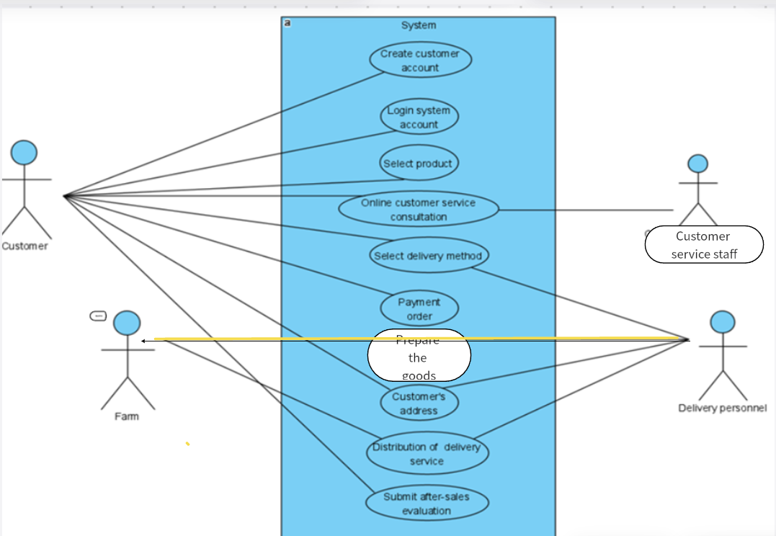

**Use Case Diagram**

# Use Case

|  |  |
| --- | --- |
| **Use case** | **Brief use case description** |
| Create customer account | This use case defines the functionality for creating a customer account. It can ensure that the customer's personal information and shipping address are stored in the system, saving a lot of trouble for the customer's business operation in the future. |
| Create customer order | This use case defines the functionality for creating customer orders. It can track the user's order type to push similar items to customers through algorithms, and it can also track the progress of user orders to provide a basis for a series of problems in subsequent orders。 |
| Distribution of  delivery service | According to the delivery address provided by the customer, the system assigns them the nearest farm for fast delivery. Systems are needed to avoid customer delivery confusion on the edge of two farms. |
| mode of payment | **Online and offline payment, pre-sale and after-sales payment.** |
| Insufficient supply | How to ask the customer to choose other products |
| Online customer service consultation | Recently, this use case defined the ability of online customer service to answer customer questions about commodities and transactions online through computer chat and telephone. This plays a crucial role in increasing customer satisfaction. |
| Customer preferences | Recommend the corresponding products and discounts according to customer preferences. |

|  |  |  |
| --- | --- | --- |
| Use case name: | Create customer order | |
| Scenario: | Create product orders based on customer selections, refine order-related matters, and match orders to the nearest farm delivery products | |
| Triggering event: | Customers want to buy agricultural products more conveniently and time-saving | |
| Brief description: | Record the phone number or product information booked by the customer in the system, determine the customer type according to the order information, ask the customer about the delivery method, and finally contact the nearby farm according to the user's address for delivery and delivery. | |
| Actors: | Customers and the system | |
| Related use cases: | Communication and confirmation of order information between customers and customer service consulting staff. | |
| Stakeholders: | Customers、Farm employees、boss | |
| Preconditions: | The client has created an account and filled in the correct contact and address. | |
| **Postconditions:** | 1. Sufficient inventory and can meet customer needs.  2. The system is running normally.  3. Delivery personnel get correct delivery information and danger tips.  4. The logistician receives feedback and stores customer purchase preferences | |
| Flow of activities: | Actor | System |
| 1. The customer logs in to the system account.  2. Choose what they want and how to pick up the goods  3. The customer pays for the goods  4. Form the order number | 1. The system displays product information and default options  2. Record the product information requested by the customer and ask about the delivery method 3. Determine whether the customer type is "regular" or "standard".  4. Generate an order and contact a nearby farm for delivery |
| Exception conditions: | 1.Incomplete customer information  2.Wrong receiving address  3.Not enough inventory to meet customer demand | |

# Activity Diagram

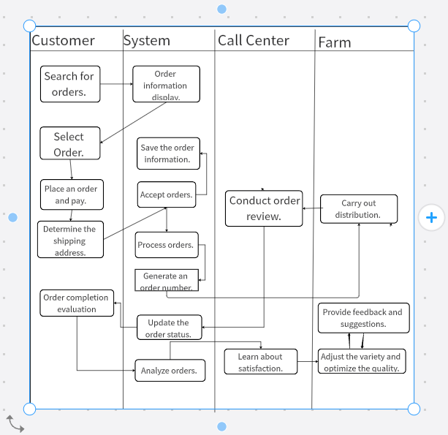

# ERD

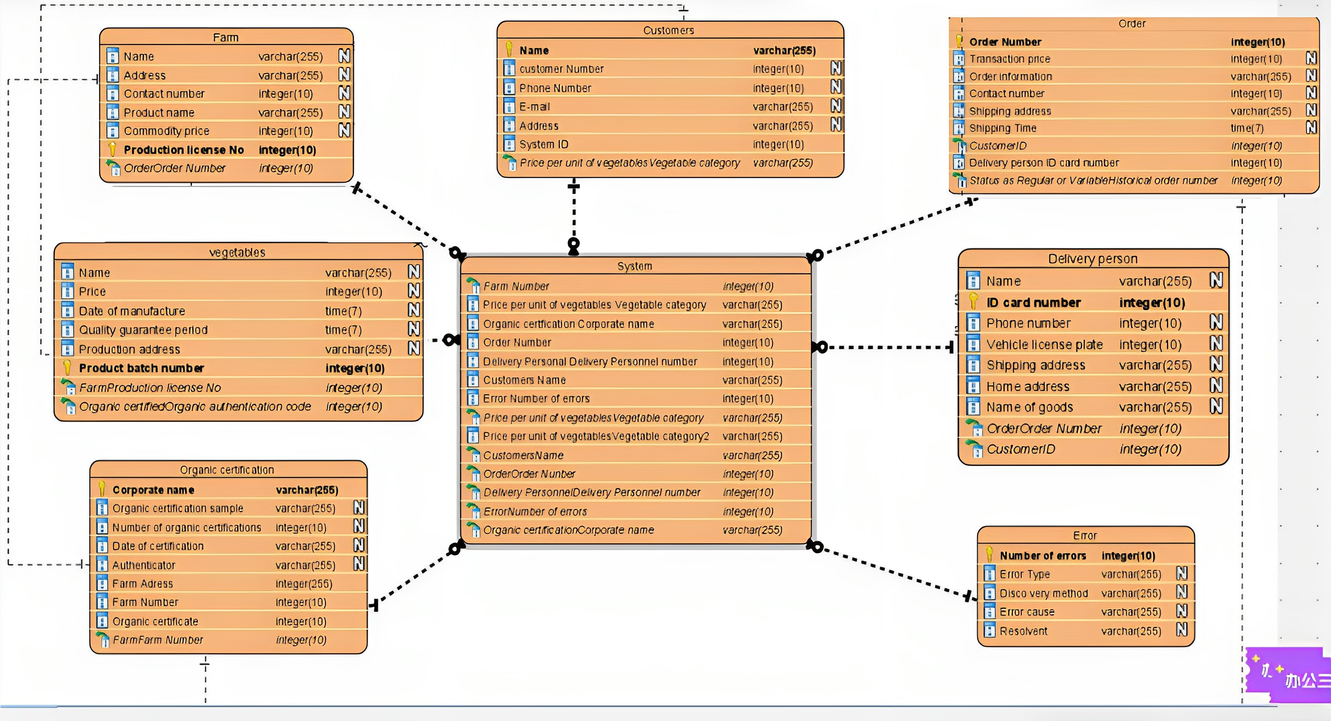

# Database Design

## Database Schema

**Customer**

|  |  |  |
| --- | --- | --- |
| Atrributes | Date Type | Notes |
| ID | integer（10） | The ID of the customer's system |
| Name | varchar（255） | Customer's name |
| Phone number | integer（10） | Customer contact information |
| Address | varchar（255） | Customer's address |
| E-mail | varchar（255） | Customer's E-mail |
| Unit price of vegetables | Varchar（255） | The unit price of the vegetables purchased by the customer |

Take two examples

|  |  |  |
| --- | --- | --- |
| Atrributes | Example1 | Example2 |
| ID | 202200408085 | 202200408086 |
| Name | Herry | Make |
| Phone number | 13978002403 | 13949657787 |
| Address | 602, building 10, 268 Taihang Avenue | 602, building 10, 268 Taihang Avenue |
| E-mail | 1584413983@qq.com | 1586756123@qq.com |
| Unit price of vegetables | grape | Freshly picked fruit |

**Farm**

|  |  |  |
| --- | --- | --- |
| Atrributes | Date Type | Notes |
| Name | varchar（255） | Farm's name |
| Address | varchar（255） | Farm's address |
| Contact number | integer（10） | Contact information of the farm |
| Product name | varchar（255） | Product name |
| Commodity price | integer（10） | Commodity price |
| Production license No | integer（10） | Production license No |

Take two examples

|  |  |  |
| --- | --- | --- |
| Atrributes | Example1 | Example2 |
| Name | Henry's organic farm | Mark's organic farm |
| Address | 211 Garden Route | 8 Taihang Avenue |
| Product name | Vegetables | Fruit |
| Commodity price | Eight dollars per kilogram | Three dollars per kilogram |
| Contact number | 0391-5628111 | 0391-5292787 |

**Order**

|  |  |  |
| --- | --- | --- |
| Atrributes | Date Type | Notes |
| Order Number | integer（10） | Order number of the transaction |
| Transaction price | varchar（255） | Transaction price |
| Order information | varchar（255） | Details about the order |
| Contact number | integer（10） | Customer contact information |
| Shipping Time | time（7） | Shipping Time |

Take two examples

|  |  |  |
| --- | --- | --- |
| Atrributes | Example1 | Example2 |
| Order Number | A1123444321 | B6654376455 |
| Transaction price | 58 dollars | 77 dollars |
| Contact number | 13978002403 | 1334567787 |
| Shipping Time | December 12, 2022 | December 13, 2022 |

**Vegetables**

|  |  |  |
| --- | --- | --- |
| Atrributes | Date Type | Notes |
| Name | Varchar（255） | Name of vegetable |
| Price | integer（10） | Price of vegetable |
| Date of manufacture | time（7） | Date of manufacture |
| Quality guarantee period | time（7） | Quality assurance for consumption within this date |
| Production address | varchar（255） | Address of the farm producing this commodity |
| Product batch number | integer（10） | Production proprietary batch |

Take two examples

|  |  |  |
| --- | --- | --- |
| Atrributes | Example1 | Example2 |
| Name | Sweet potato | Spinach |
| Price | Four dollars per kilogram | Five dollars per kilogram |
| Date of manufacture | 2023.10.28 | 2023.10.29 |
| Quality guarantee period | 2023.10.30 | 2023.12.1 |
| Production address | Henry's organic farm | Mark's organic farm |
| Product batch number | QQ1584413983 | QQ1593990243 |

**Delivery person**

|  |  |  |
| --- | --- | --- |
| Atrributes | Date Type | Notes |
| Name | varchar（255） | Name of delivery person |
| ID card number | integer（10） | ID card numberof delivery person |
| Phone number | integer（10） | Contact information of delivery person |
| Vehicle license plate | integer（10） | Vehicle license plate |
| Shipping address | varchar（255） | Delivery address filled in by the customer |
| Home address | varchar（255） | Delivery person’s home address |
| Name of goods | varchar（255） | Name of goods |

Take two examples

|  |  |  |
| --- | --- | --- |
| Atrributes | Example1 | Example2 |
| Name | Alice | Max |
| ID card number | 11122336543 | 02134563455 |
| Phone number | 13978002403 | 13849518787 |
| Vehicle license plate | A02254 | S55623 |
| Shipping address | 602, building 10, 268 Taihang Avenue | 603, building 10, 267 Taihang Avenue |
| Home address | 32, building 7, 268 Taihang Avenue | 66, building 17, 268 Taihang Avenue |
| Name of goods | Cabbage | Eggplant |

**Organic certification**

|  |  |
| --- | --- |
| Atrributes | Date Type |
| Corporate name | Varchar (255) |
| Organic certification project | Varchar (255) |
| Number of organic certifications | Integer (10) |
| Authenticator | Varchar (255) |
| Date of certification | Varchar (255) |

Take two examples

|  |  |  |
| --- | --- | --- |
| Atrributes | Example1 | Example2 |
| Corporate name | Jack‘s’ | Sarck‘s’ |
| Organic certification project | tomato | Potato |
| Number of organic certifications | 1 | 1 |
| Authenticator | E.B White | E.B White |
| Date of certification | 2023/8/11 | 2023/9/15 |

**Error**

|  |  |
| --- | --- |
| Atrributes | Date Type |
| Number of errors | Integer (10) |
| Error Type | Varchar (255) |
| Discovery method | Varchar (255) |
| Error cause | Varchar (255) |
| Resolvent | Varchar (255) |

Take two examples

|  |  |  |
| --- | --- | --- |
| Atrributes | Example1 | Example2 |
| Number of errors | 1 | 2 |
| Error Type | Human error | System error |
| Discovery method | Staff | Customers |
| Error cause | System crash | Operation error |
| Resolvent | Update system | Strengthen training |

**System**

|  |  |
| --- | --- |
| Atrributes | Date Type |
| Farm Number | Integer (10) |
| Price per unit of vegetables | Varchar (255) |
| Organic certfication Corporate name | Varchar (255) |
| Delivery Personnel number | integer(10) |
| Customers Name | Varchar (255) |
| Order Number | integer(10) |
| Error number of errors | integer(10) |
| Organic certification Corporate name | varchar(255) |

Account(**accountID**, accountType, dateOpened, balance**,** *custNumber, branchID*)

## Alternative Options

|  |  |  |  |
| --- | --- | --- | --- |
| **Name of package** | **In-house development system** | **Sage 50** | **EHR** |
| **Cost** | **60000** | **55000** | **78000** |
| **Features** | **At its core, there is a robust approval workflow.**  **1.Flexibility : In-house developed systems can grant access to employees according to their different roles and responsibilities. 2. Serviceability: The system should be easy to maintain and update to reduce operating costs and improve the reliability of the system. 3.Security : The system adopts various security measures, such as access control, data encryption, and security auditing, to protect data from being leaked or accessed by unauthorized persons. 4.Customization : This means that the system can be designed and developed according to the business processes, preferences and goals of the enterprise.** | **1. Easy to operate. Sage 50 is an easy-to-use accounting software that allows non-accountants to organize their business.**  **2. Realize real-time data sharing across departments. Realize data sharing and interaction between finance, procurement, sales, human resources and other departments, and improve the coordination efficiency and decision-making analysis level within the enterprise.**  **3. Achieve sophisticated financial analysis. Segment and analyse financial data to support enterprise decision-making and planning.** | **1 Standardization: The management between enterprises is different, so the personnel management system should have different structures and functions in different enterprises.**  **2. Consistency: All individual human resource practices serve the same enterprise's competitive strategic objectives, and there should be consistency between human resource management activities and enterprise development stages.** |
| **Support** | **1. Improve efficiency Internal management system can automate and optimize the business process of the enterprise, reduce manual operation and duplication, improve work efficiency, and improve the quality and accuracy of employees' work.**  **2. Improve customer service quality: Internal management systems can help customer service teams better manage and follow up customer information.** | **The system of Sage 50 consists of financial, sales, inventory, purchasing, production, cost and other modules.**  **1. It integrates the information of various departments to achieve information sharing. Improve the overall operational efficiency of the enterprise.**  **2. It goes online quickly, saving time and cost. Save costs and reduce labor input**  **3. It is centrally managed, distributed and used, and implements the group's management methods, orders and process integration.** | **With the help of information technology, create a new management mode to save energy and time for more important functions, thus directly improving the enterprise's ecological environment and promoting the sustainable progress and development of the organization** |
| **Deployment method** | **The new office mode combines the functions of modern office and computer network, and is a very active and dynamic technical application field in the current new technological revolution, and is the product of the information society. With a network, people in your organization can work together across time and place. Through the switching network application realized by the system, the information transmission is faster and more convenient, and the office means are greatly expanded and the office efficiency is realized.** | **The Sage 50 system is a widely used financial and business management software that typically includes functions such as accounting, human resources, sales, and supply chain management. However, you have the flexibility to choose and customize different modules of your Sage 50 system to your specific needs and the size of your business. You have the option to add a Commerce module to better manage your online selling business. This module helps you track inventory, process orders, and ensure that your e-commerce site integrates seamlessly with the Sage 50 system to better meet your business needs.** | **EHR system is an electronic health record system, which usually contains personal health information, medical records, medical records and other related information. However, you can combine different modules to meet your specific needs depending on your needs and the size of your business. For example, modules such as chronic disease management, family health records, etc. to better manage and record your health information. By choosing the EHR module that suits your needs, you can increase efficiency and streamline your health management process. The flexibility and scalability of an EHR system make it a reliable health management solution.** |
| **Contact Details /Website** | **021-1255-676** | **022-9776-235** | **034-4335-345** |

## Analysis

I think each system has its uniqueness, but the in-house developed system is the better of the three。**1. EHR** is a new human resource management model based on advanced information and Internet technology, which can reduce costs, increase efficiency, and improve employee service models. By introducing EHRs, enterprises can reduce the burden of human resource management, optimize human resource management processes, improve the service quality of human resource management departments, and provide decision-making support, thereby helping enterprises achieve strategic human resource management transformation. Any activity that uses or introduces various human resources management tools can be referred to as "e-HR". However, with the development of internet and e-commerce concepts and practices, what we now call "EHR" has been given a new meaning. It is a new human resource management model that integrates the core ideas of "e-commerce", "Internet", "human resource business process optimization (BPR)", "customer-oriented", "comprehensive human resource management" and so on. Its information permissions can be viewed. In addition to ordinary EHR practitioners, ordinary employees, managers, and presidents will interact with the EHR foundation platform with the appropriate permissions. In general, EHR is a new human resource management model, representing the development direction of human resource management in the future. It is a new office mode that combines modern office and computer network functions, and is a very active and dynamic technical application field in the current new technological revolution, and it is also a product of the information society. With a network, people in your organization can work together across time and place. **2.** **Sage 50's** model uses cloud computing technology to make financial management easier and more efficient. Its advantage is, first of all, that it reduces the cost of the enterprise. Businesses don't need to buy and maintain expensive hardware. Second, it improves the efficiency of the enterprise by storing all the data in the cloud. So that users and businesses can access and update anytime, anywhere. Finally, it improves the company's customer service model so that customers can view their personal and financial information anytime, anywhere. The main purpose of Sage 50 is to drive innovation and application of financial management. By using Sage 50, organizations can achieve strategic financial management, optimize management processes, and improve the quality of financial management services. It also provides decision support to enterprises. This not only contributes to the competitiveness of the enterprise, but also benefits its sustainable development.**3.** With the exchange network application that my **in-house development system** can implement, the transfer of information becomes faster and easier. It expands the way of working and increases productivity. At the same time, with the continuous development of technology, the evolution of employees' working methods and habits, and the transformation of management concepts, my system definition is also constantly changing. At each stage of the technological development process, my system has also been given different content and new imagination, and people in different industries and at different levels have different views and understandings of my system.

In general, my in-house developed system is a collection of almost all the information processing and management of the enterprise. It is aimed at different levels of users with different features. For senior leaders, my system provides decision support, based on scientific mathematical models, combined with internal and external information of the company, to provide reference and basis for leaders. For middle managers, my system is an information management system that extracts useful management information and masters business processes by using the basic data provided by each link of the business. For the average employee, my system is a trading and business processing system. It can provide office workers with an accurate, efficient and enjoyable working environment and tools.

**Recommendation**

I recommend **building in-house**. There are many factors to consider when choosing a package, an in-house build, or a custom build. For example, budget costs, basic policy requirements, technical capabilities, team size, etc. The advantage of **purchasing a package** is that it saves time and resources. The software package is characterized by easy installation and installation, and it has ready-made features that do not require time-consuming development. Software packages are usually regularly tested to detect problems and be optimized for the purpose of optimization. Purchasing software packages can reduce development and maintenance costs. However, it has the disadvantage of not being able to meet the specific needs of Henry's system. Because its functionality is predefined. In addition, it also has the disadvantage of security and licensing problems. Henry's farm needed a system that matched the specific needs of the farm. Therefore, the Sage50 package is not the best choice of the three. The advantage of **building it in-house** is that it can be customized to better meet the needs of your organization. In addition, software is built in-house for better control. In the case of knowing the appeal to Henry Farm, the interior construction is the best option. When businesses have specific needs that cannot be met by purchasing ready-made packaging, interior architecture becomes very attractive. The internal build gives the system a wider range of flexibility and freedom. Businesses can build this system based on the specific needs and business processes required by Henry Farm. In addition, building in-house can improve the core technical capabilities of the enterprise while also increasing the range of professional knowledge and skills of employees. By building in-house, companies can cultivate their own development teams, making them more proficient in the business and processes of the enterprise. This allows companies to better maintain and update their software systems. But there are some risks associated with building in-house. It requires a lot of time and resources to prepare, and it requires the company to have a certain amount of technology. In the process of development, enterprises have to face some unknown problems and difficulties. This requires a high level of technical skills and problem-solving skills. In short, interior architecture offers more flexibility and freedom, but it also requires an investment of effort and resources. **Custom builds** are basically the same as internal builds, which refer to software development and application customized by external software development companies or teams according to the specific needs of the enterprise. The advantage of this approach is that it leverages the expertise and experience of external software development companies to ensure the quality and performance of software systems. At the same time, it can also improve development efficiency. However, it has the disadvantage that it requires a lot of time and resources and requires specialized technology. However, custom builds can cost more than building them in-house。

It meets the special needs of customers and is also the center of almost all information processing and management of the enterprise. At the same time, it is cheaper to produce than custom construction. **To sum up, better option to choose is build in-house.**

**Conclusions**

An analysis of the new system concluded that the system was highly functional and adaptable, and that it was efficient to achieve its objectives and provide for Henry Farms needs. And the system is able to run fast under high loads. In terms of security, the new system adopts encryption technology and security measures to protect customers' privacy and personal information. The new system is easier to use than outsourced software, user-friendly and in line with user habits. At the same time, the new system has better integration with other systems, which can realize the seamless connection and exchange of data. Easy to unify information on Henry Farms with other farms. From a cost-benefit point of view, the system has a high return on investment. Its high rate of return also brings long-term economic benefits to the enterprise. All in all, after a thorough analysis of the new system, we can conclude that the new system is an excellent software product that is powerful, secure, easy to use and cost-effective for users. In addition, the new system is maintainable and expandable. The structure of the new system is refined, so that it can be modified and maintained. At the same time, it can make itself easily expand and upgrade. These features enable the new system to operate stably and efficiently over the long term.

In summary, through the comprehensive analysis of the new system, we know that the system is an excellent software product with strong functions, high performance, good security, good usability and user experience, compatibility and cost-effectiveness. It not only meets the needs of users, but also brings long-term economic benefits, while also integrating the specific requirements of farm development.

# Bibliography

“Improve service level.’’(John S. Robert J. Stephen B. 2017 *System analysis and design: agile iterative methods 6th ed. Beijing: machine press page204*)

“Improve customer satisfaction”(John S. Robert J. Stephen B. 2017 *System analysis and design: agile iterative methods 6th ed. Beijing: machine press page204*)

‘’System prompts for customer address.”(John S. Robert J. Stephen B. 2017 *System analysis and design: agile iterative methods 6th ed. Beijing: machine press page92*)

“System prompts for customer address.”(John S. Robert J. Stephen B. 2017 *System analysis and design: agile iterative methods 6th ed. Beijing: machine press page92*)

**“Agrivi”**MatijaZulj2013 website:<https://www.capterra.com/p/>136084/Agrivi/